COVID-19 Mitigation Plan

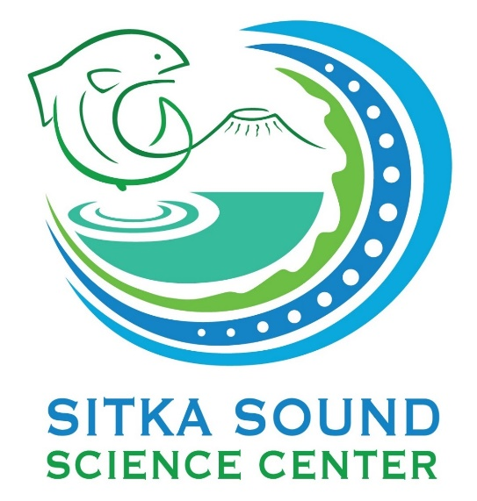The Sitka Sound Science Center has developed and continues to update our policy to mitigate the risk of COVID-19. This document outlines our efforts to keep our staff and visitors safe based on the current information. All of the following guidelines apply to the SSSC Aquarium, Gift Shop, and Ludvig’s Chowder Cart.

Homework Tips Checklist for Parents

# Community Safety

**No person exhibiting symptoms consistent with COVID-19 or other illness will be allowed on SSSC grounds.**

Staff members are undergoing daily health screenings prior to entering the building.

Any staff member displaying symptoms of illness is isolating and working from home.

# Social Distancing

Face coverings must be worn by all staff and visitors over the age of 5 years and recommended for children between 2 and 5 years.

Please help us by staying conscious of the distance between you and other people. **Maintain at least 6 feet of distance between yourself and any person outside your household.**

Groups must be limited to household members only.

Social Distancing

# Cleaning and Hygiene

Additional hand sanitizing stations have been placed throughout the buildings. Please use hand sanitizer on your way in and out.

We encourage everyone to wash hands frequently. Handwashing sinks are located in the restrooms.

**SSSC is sanitizing all common surfaces every hour.** This includes the entryway, touch tanks, aquarium signs, bathrooms, counters, and other surfaces commonly touched.

In addition to hourly sanitizing, SSSC also cleans and sanitizes all surfaces every week in accordance with state and CDC guidelines.

# SSSC Aquarium

The aquarium is open to the public by **reservation only**. Go to [www.sitkascience.org](http://www.sitkascience.org) to make reservations.

Payment for reservations must be done online during the reservation process. To reduce the use of touch screens, we will not be accepting payment at the door.

SSSC is limiting the number of people and groups in the aquarium to maintain social distancing. No more than 8 people will be admitted during one reservation block.

Visits are limited to 1 hour to allow our staff time to sanitize common surfaces.

# SSSC Gift Shop

The gift shop is open and will continue to offer online and contactless delivery.

All transactions are cashless. Receipts can be emailed to you after purchase.

Please limit household party size in the SSSC gift shop and maintain at least 6 feet of distance between yourself and any person outside your household.