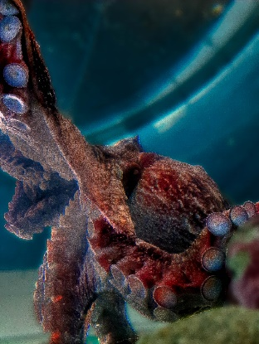
How much does a Giant Pacific Octopus eat?
Pearl weighs about 50 pounds! Sandy measures enough herring, salmon, shrimp, or crab to equal 3% of her body weight every time she feeds her.
What is the weight that Sandy must measure?
If Sandy feeds Pearl 3 times a week during the spring, how much is she fed per week?

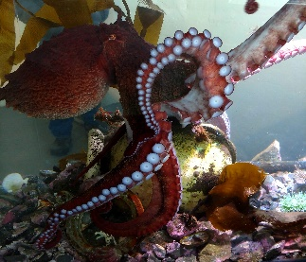
How many suckers does a Giant Pacific Octopus have?
A Giant Pacific Octopus (GPO) has about 200 suckers on each arm.
Based on that information, how many suckers does Pearl have in all?

Answer Box
How much does an octopus eat?
To find how much 3% of 50 pounds is, Sandy would multiply 50 by 3%.
50 X 0.03 = 1.5 pounds (lbs) each feeding
In the spring, Sandy feeds 3 times a week, so 1.5 lbs X 3 = 4.5 lbs each week
In the summer, Sandy may feed 7 times a week, so 1.5 lbs X 7 = 10.5 lbs each week

How many suckers does an octopus have?
If each arm has about 200 suckers and an octopus has 8 arms, then 200 X 8 = 1600 suckers!

